DATA ANALYTICS WITH R, EXCEL AND TABLAEU

ASSIGNMENT Excel Analytics 30.2

ANSWERS

4. Associated Data Files

Use “Widget sales - IF question.xlsx”

5. Problem Statement

- Create an If function to calculate a total order value based on the following criteria:

  - If less than 1000 units are ordered each unit costs the normal price

- Otherwise each unit costs the discounted price

Ans

=IF(D5<1000,"normal price","discount price")

• Copy the formula down and check that it works.
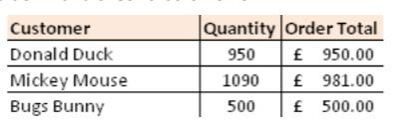

• Save the file with the same name and upload it as part of deliverable

